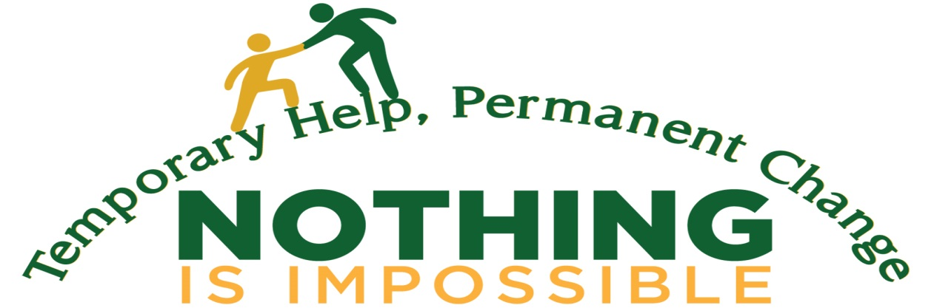

NOTHING IS IMPOSSIBLE’S 14TH ANNUAL GOLF OUTING
SPONSORSHIP OPPORTUNITIES
BALLYOWN GOLF CLUB, HARDYSTON, NJ
THURSDAY, SEPTEMBER 12, 2019 – 10:00 AM REGISTRATION
PLEASE JOIN US FOR THE ULTIMATE NORTHWEST NJ GOLF EXPERIENCE

Dear Friend:

Can you believe that September 12, 2019 will mark the 14th Annual Nothing Is Impossible Golf Outing? I’m sure that you’ll agree that each and every outing has provided us memories of occasional good golf, but more importantly, good times with good friends. We are writing once again to request your continuing support for this spectacular day. As I’m sure you are aware, many of our friends and neighbors are going through difficult times and it is particularly important that we continue to assist those, who but for our aid, might slip through the cracks.

Ballyowen Golf Club is situated in the scenic rolling hills of Sussex County. A links style course, it is sure to evoke visions of Ireland and Scotland and losing valued golf balls into the fescue. From the kilted starter to the bag piper at dusk, it is truly a tremendous venue for a day of golf and friendship.

For additional information on Ballyowen and its sister courses, go to www.crystalgolfresort.com.

This year we once have a variety of ways that you can participate as a sponsor, participant or both.

PLATINUM SPONSOR - $5,000
This prestigious sponsor will include 2 foursomes and 9 tee/green signs

GOLD SPONSOR - $3,500
Join us at the Gold Level and your group will get 1 foursome and 9 tee/green signs

SILVER SPONSOR - $2,500
Silver level sponsor will get 1 foursome and 6 tee/green signs

BRONZE SPONSOR - $1,500
Bronze sponsor will get 1 foursome and 1 tee/green sign

We also have non-golf sponsorships available:

Breakfast Sponsor – 2 @ $1,000 }
Dinner Sponsor – 2 @ $ 2000 } includes
Cocktail Hour Sponsor- 2 @ $1,500 } a foursome
Beverage Cart Sponsor- 2 @ $1,000 }

Individual golfers are encouraged to participate at $200.00 per golfer. If you hurry and register and pay before August 15th you can sign up at $185 each. Foursomes get the same deal: $800 per group, discounted to $740 before August 15th!

Tee/Green/Longest Drive and Closest to the Pin Sponsors are available at $150

We are also looking for logoed or other merchandise for golfer’s gift bags (tees/golf balls/towels/hats, etc.) Each golfer will receive their “goody bag” at registration.

Lastly, we are seeking items such as sports memorabilia, golf related gifts, etc. for our silent auction.

All donors and sponsors will be acknowledged during the outing, at the awards presentation and on our website. Sign up early to make sure that your company name is mentioned in our pre-outing mailers.

We look forward to seeing you once again on Thursday, September 12, 2019 at the beautiful Ballyowen Golf course!

With our sincerest thanks,
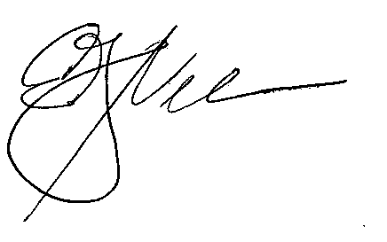
Ed Nelson
Golf Chairperson
enelson@mklaw.us.com
NOTHING IS IMPOSSIBLE

14TH ANNUAL GOLF OUTING

Sponsorship Registration

Name: ___________________________________ Phone: _______________________

Address: ___________________________City: _____________ State: ____ Zip: _____

Email: _______________________________

Name / Artwork for signage: _______________________________________________

I would like to sponsor the following: (please X next to your choice)

PLATINUM: ____ GOLD : _____ SILVER: _____ BRONZE: _____ $5,000 $3,500 $2,500 $1,500

BREAKFAST: _____ BEVERAGE CART: _____
2@ $1,000 2 @ $1,000

DINNER: ______ COCKTAIL HOUR: ______
2@ 2,000 2 @ $1,500

LONGEST DRIVE / TEE / GREEN / CLOSEST TO THE PIN: 4 @ $150.00 each
INDIVIDUAL GOLFERS: $200; BEFORE AUGUST 15TH $185

FOURSOMES: $800; BEFORE AUGUST 15TH $740

I am unable to play this year, but please accept my donation to Nothing Is Impossible, Inc. in the amount of $_____________.

Join us for dinner _____ (# of guests) @ $50.00 per person.

Please make checks payable to:
Nothing Is Impossible, Inc.
A 501(c) 3 corporation / Fed ID # 22-1867508

Please return this form as well as any gift bag items to:

Edward F. Nelson
Nothing Is Impossible, Inc.
c/o McGivney Kluger & Cook, PC
243 Sparta, NJ 07871
(973) 726-4958 enelson@mklaw.us.com

